# SharePoint API Documentation

Contents

SharePoint API Documentation 1

Introduction 1

Authentication/Authorisation 1

Authentication Methods 1

OAuth 1

Authorisation scopes 1

Scope: 1

Token Management 1

Identities required 1

Steps to get Site ID: 1

Steps to get Drive ID 2

Permissions/Roles 3

API Endpoints/URL/URIs 3

References 3

## Introduction

The SharePoint API allows developers to interact with SharePoint data programmatically. This API exposes various resources, such as site collections, lists, documents, and permissions to specifically set up SharePoint sites

Use-case:

SharePoint Name: Project Name --> Use case

* Finance_Reporting: Finance Project – Cost Center Reporting & Vertical P&L
* customer_support_services: Data Engineering – Our own SharePoint

## Authentication/Authorisation

Authentication Methods

OAuth

Authorisation scopes

Scope: https://graph.microsoft.com/.default

Token Management:

Access Token

Identities required

* Tenant ID – A unique identifier for your organization in Azure AD.
* Client ID – A unique identifier for your registered application in Azure AD.
* Client Secret – A secret string used to authenticate your application to Azure AD.
* Drive ID – A unique identifier for a software driver (context-specific, not common in SharePoint).
* Site ID – Unique identifier for a SharePoint site collection.

Tenant ID, Client ID, Client Secret are obtained through the Azure Portal respectively to the App registration

Site ID & Drive ID are obtained through Microsoft Graph Explorer or can be obtained through the SharePoint site itself.

### Steps to get Site ID:

Site name is a unique name for a SharePoint site that a team/department use to stored data and files within.

1. Go to: <https://developer.microsoft.com/en-us/graph/graph-explorer>
2. Log into your personal 80hg.io/correla.com account
3. In the URL Field input the following:  
   Format: [https://graph.microsoft.com/v1.0/sites?search={SITE_NAME}](https://graph.microsoft.com/v1.0/sites?search=%7bSITE_NAME%7d)

Example: <https://graph.microsoft.com/v1.0/sites?search=CustomerSupportServices>  
Ensure you are using a GET and v1.0  
Select ‘Run Query’

1. You should see a success “*OK – 200*” status code. Below this status code you will see a list of items one of the items being **id**, this **id** field is your **site id**

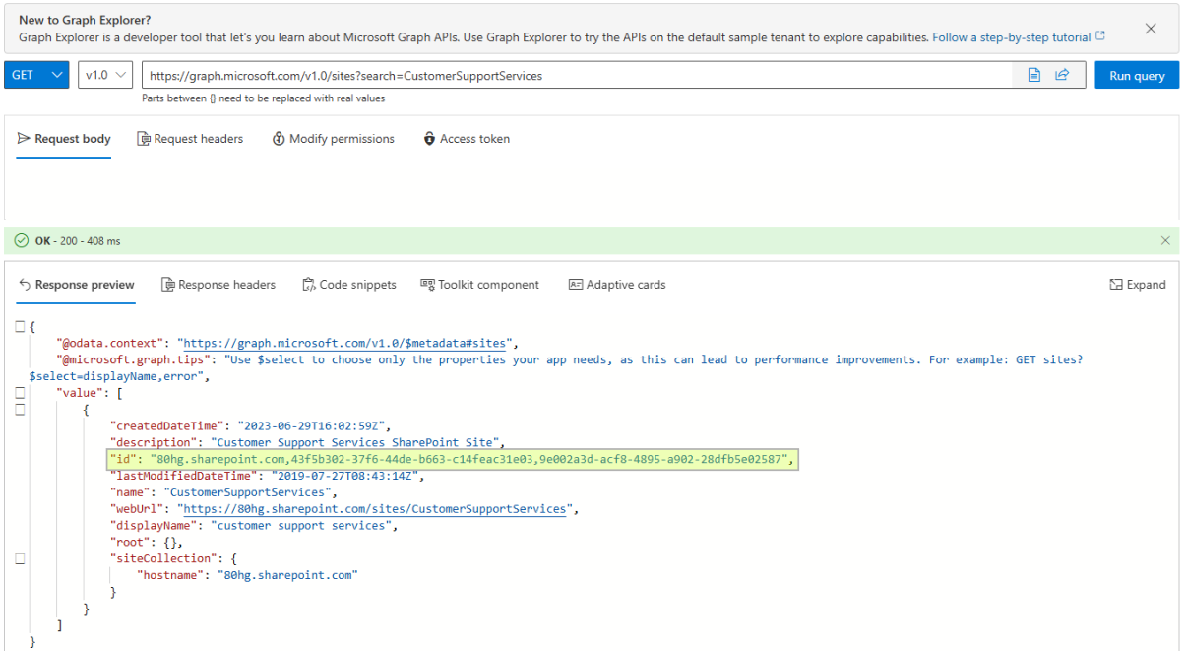

### Steps to get Drive ID

Note: Drive ID is one of the folders before the directory. Majority of the time, files and data are stored in the Documents (Shared Documents) part of the SharePoint site. In the screenshot below we have 2 drives: Business Intelligence or Documents (Shared Documents).

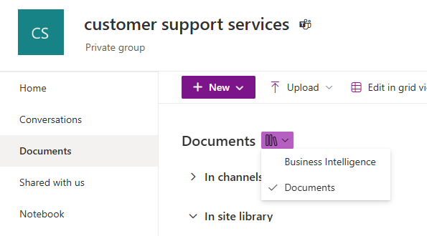

1. Now you have the site id from above, copy this value  
   Replace the new URL with the following:  
   Format: [https://graph.microsoft.com/v1.0/sites/{SITE_ID}/drives](https://graph.microsoft.com/v1.0/sites/%7bSITE_ID%7d/drives)  
   Example: <https://graph.microsoft.com/v1.0/sites/43f5b302-37f6-44de-b663-c14feac31e03/drives>  
   Ensure you are using a GET and v1.0  
   Select ‘Run Query’
2. You should see a success “*OK – 200*” status code. Below this status code you will see a list of items one of the items being **id**, this **id** field is your **Drive** **id**

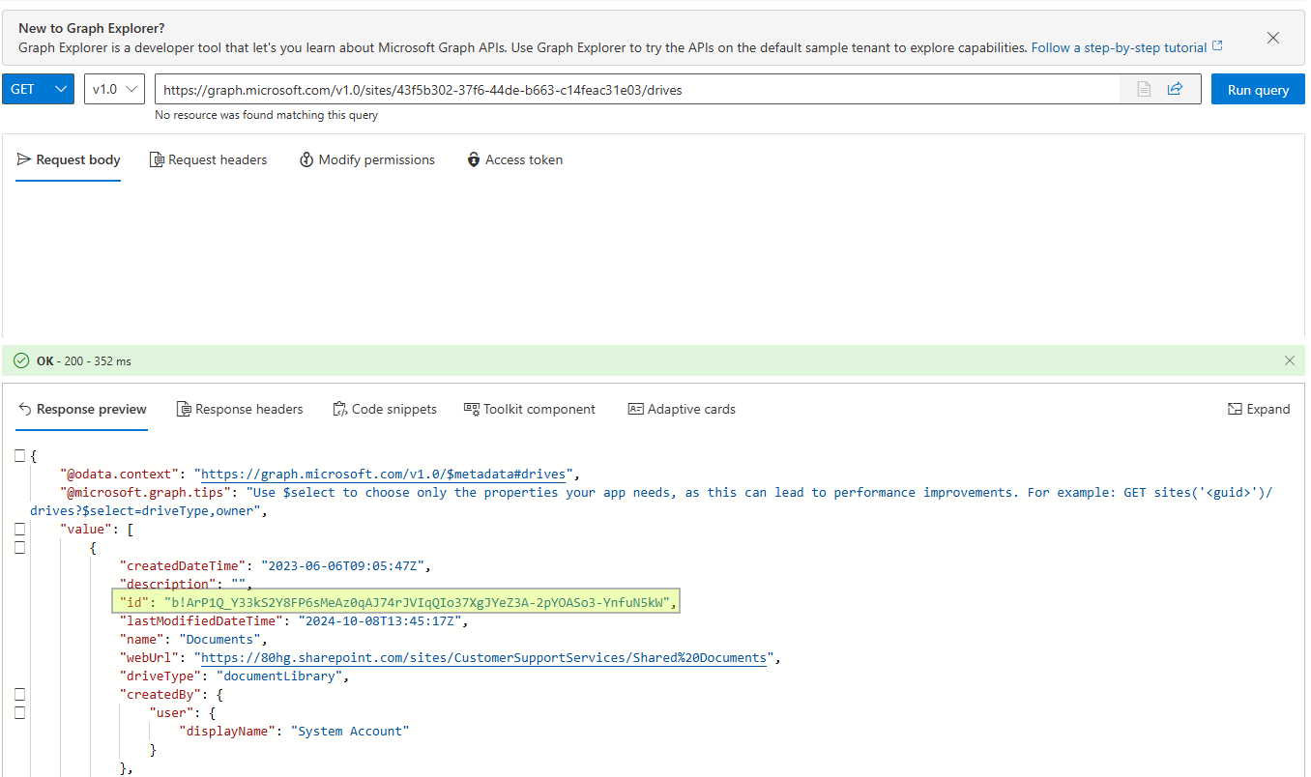

Permissions/Roles

App registration permissions:

* Application permissions
  + Sites.Selected
  + Files.ReadWrite.AppFolder

Microsoft Graph permissions

## API Endpoints/URL/URIs

This part is done in Microsoft graph to update the permissions. We are using POST to push permissions to the specified SharePoint site however the application itself will only have GET as per the roles in the request body.

**Method**: POST

**URL**: <https://graph.microsoft.com/v1.0/sites/586278d7-bd07-4e9d-8222-b3ffb985159d/permissions>

**Request headers**:

|  |  |
| --- | --- |
| Content-Type | application/json |

**Request Body** *(To be done by admin user)*:

{

"roles": [

"read"

],

"grantedToIdentities": [

{

"application": {

"id": "e0255a6a-013b-4f16-8f26-ecd20a92b04f",

"displayName": "FinanceReporting_SharePoint_RestAPI_MSGraph"

}

}

]

}

**Success response**: 200

**Error response**: 400*

* Any 400, 401, 402, 403, 404 error codes

## References

<https://readmedium.com/python-read-and-send-outlook-mail-using-oauth2-token-and-graph-api-53de606ecfa1>

<https://python.plainenglish.io/all-you-need-to-know-file-handing-in-sharepoint-using-python-df43fde60813>

<https://learn.microsoft.com/en-us/answers/questions/730575/how-to-find-site-id-and-drive-id-for-graph-api>